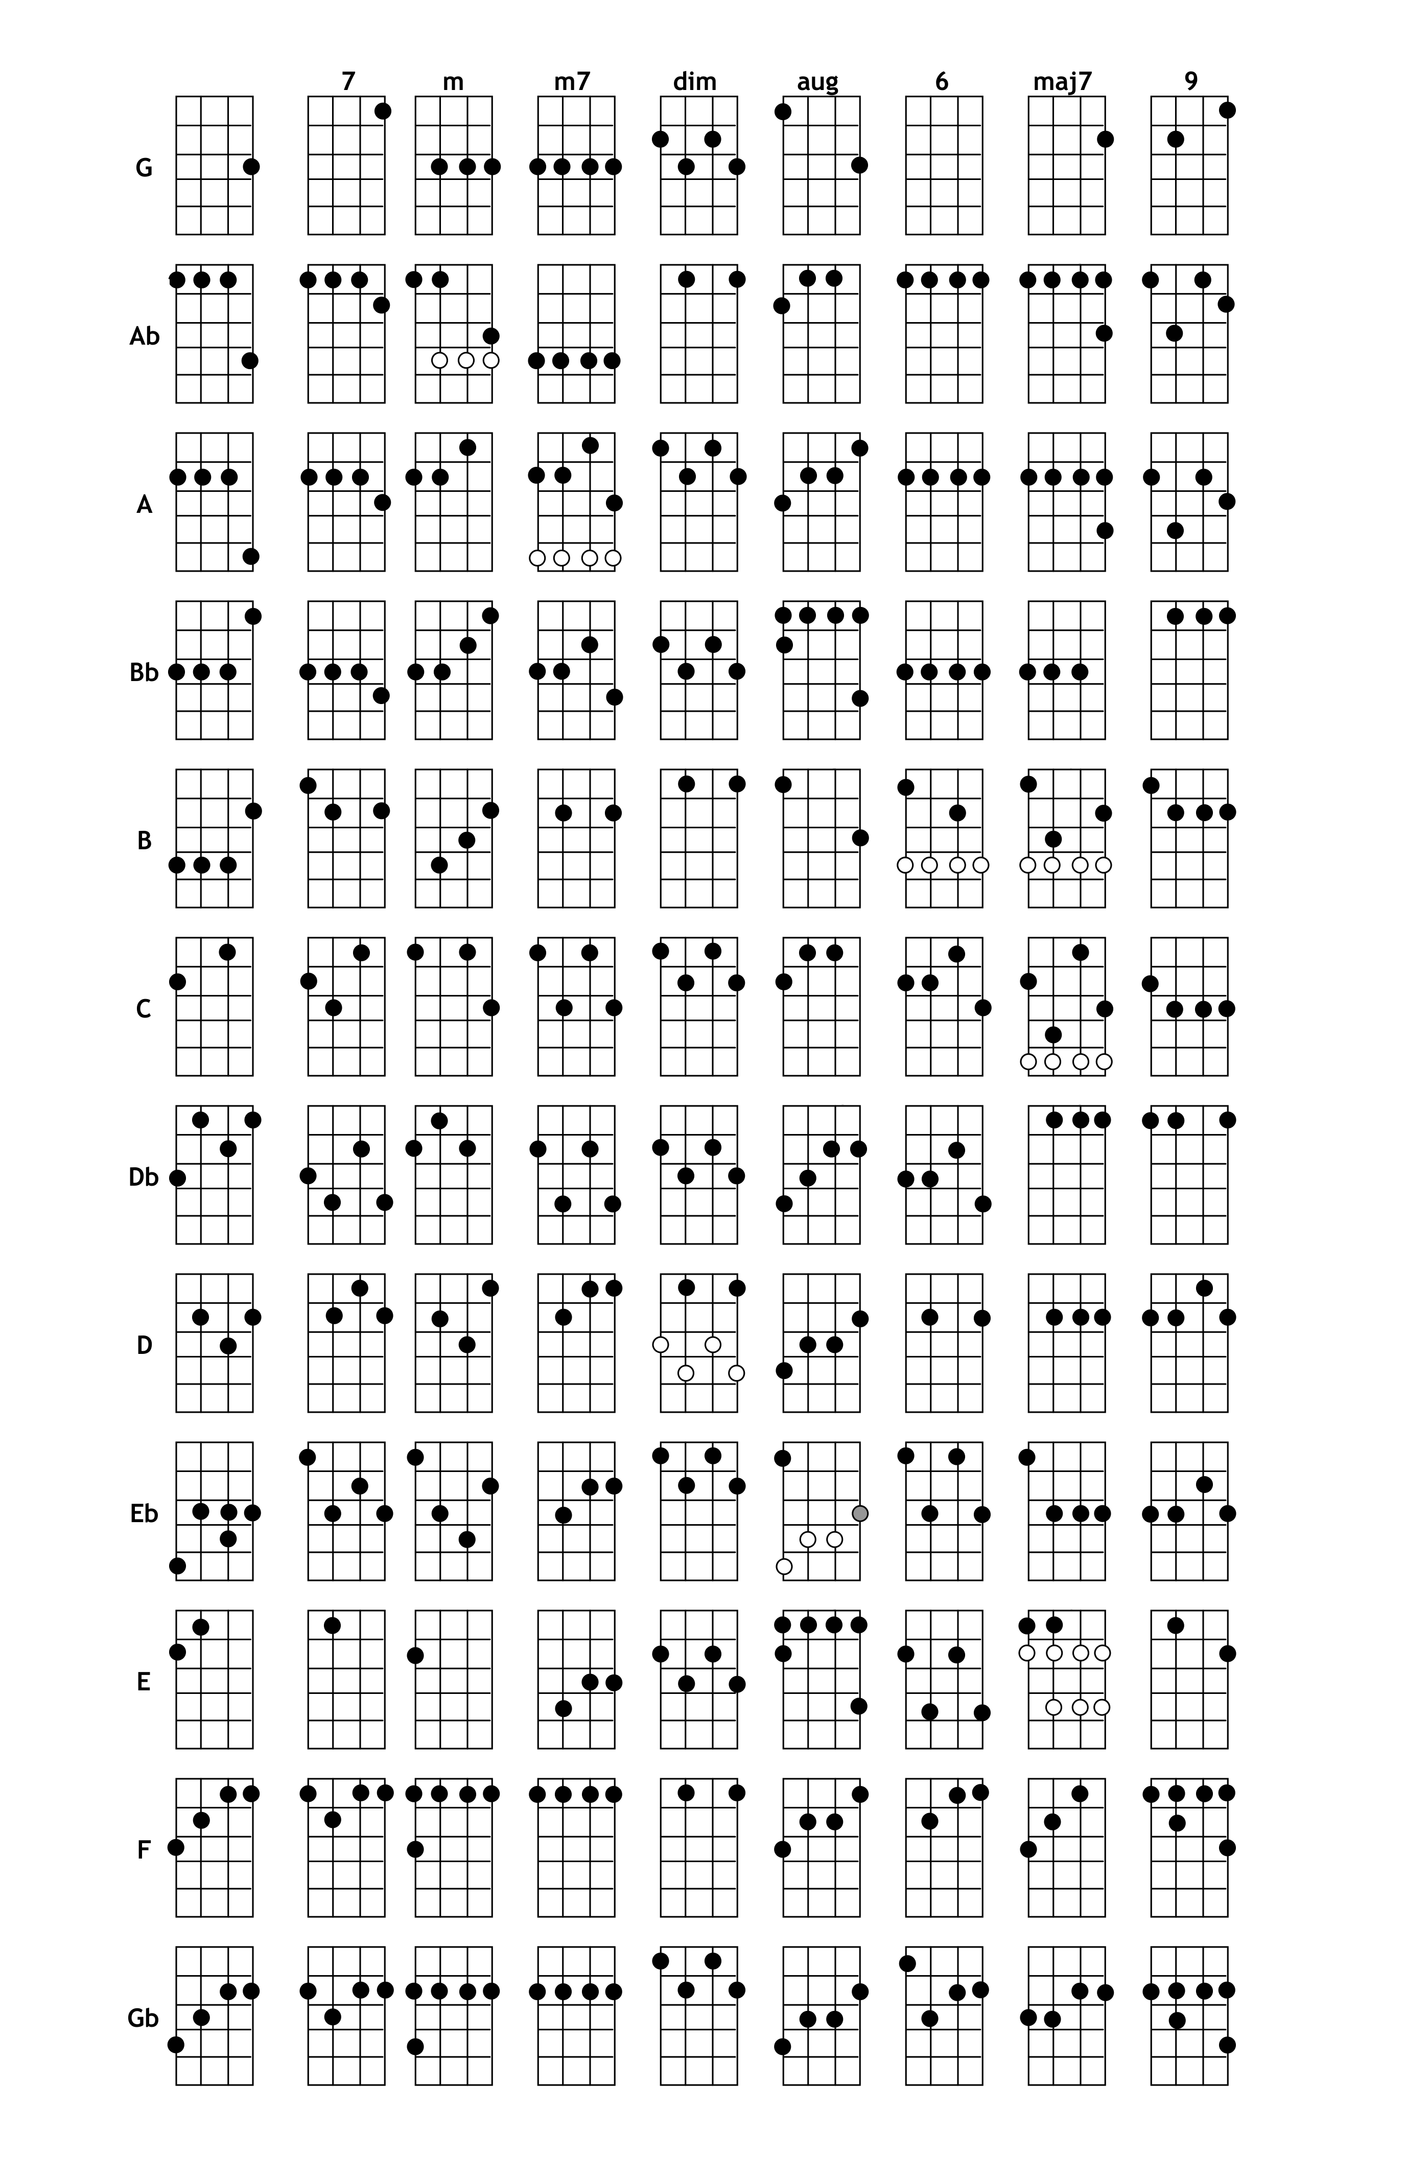
DGBE Tuning Chord Chart

